**Tips for IELTS Listening Map Labeling:**

1. Read the instructions carefully; this is so you know what you need to do and the maximum number of words and/or numbers you can use—in this case, no more than two words or write the correct letter, A–I.
2. Be familiar with location-related vocabulary: You must be familiar with terms that are frequently used to describe a location.
3. Determine where each number begins and ends. For example, if the first map question begins with "21" and the total questions are 5, the next questions "21–25" will appear in the listening order.
4. Look at two questions at once—this is something you should always do in the listening test. If you hear the answer to question 22, you will know you missed question 21. Forget about this and move on, or try to guess the answer to question 21, but don’t affect your next question 23 by thinking about question 21.
5. Understanding the context can help you follow the speaker's talk; pay special attention from beginning as they provide information. Examine the map properly which will help you in determining precisely what you are labeling; take note of the items that have previously been labeled to get an idea of where things are located.
6. Predict the answers - as with the entire listening test, it helps to predict what the answer may be. Look at the gaps and see if you can guess what you are labeling - a room, building, sports facility, street etc.?
7. Pay attention to any further clues provided by the map, such as where "North," "South," "East," and "West" are located.
8. Don’t be distracted by extra information.
9. Don’t forget to make notes but don’t write longs words, simply use abbreviations or simple letters.

Questions 1- 6

Label the map below. Write the correct letter, A-K, next to Questions 1-6. WALKING TOUR

MAP OF THE NATIONAL BOTANICAL GARDEN

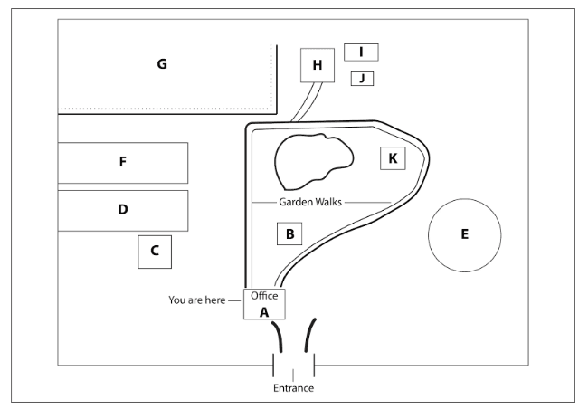

1. Nursery --------------

2. Native tree zone --------------

3. Exotic forest zone--------------

4. Exhibition --------------

5. Shamiana --------------

6. Topiary display -------------

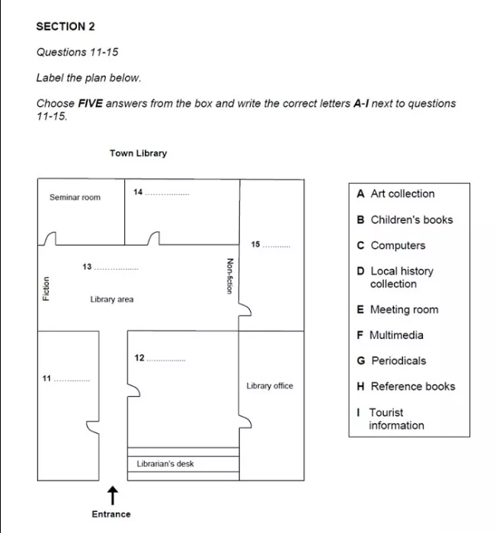

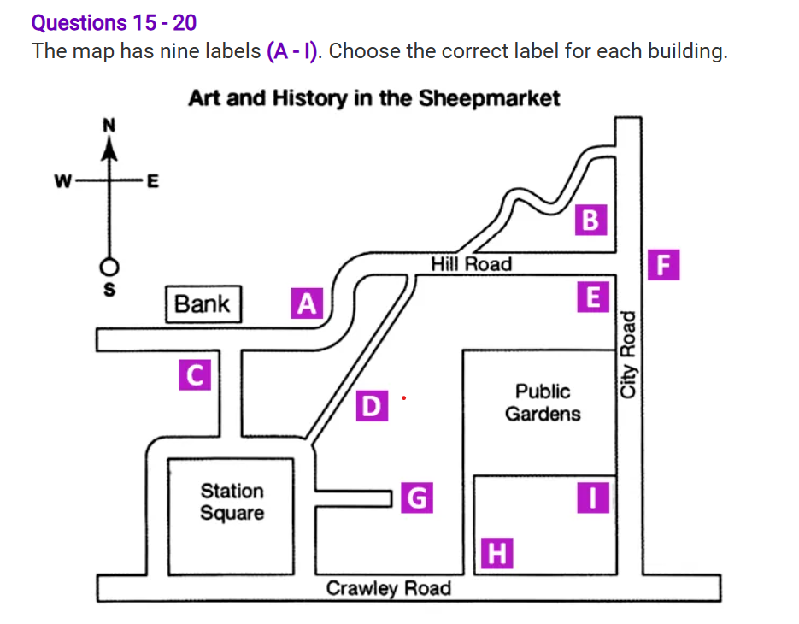

15. The reynolds house ____________

16. The thumb ____________

17. The museum _________

18. The contemporary art gallery ___________

19. The warner gallery __________

20. Nucleus _________

